# **General Questions**

### 

### **Q1. What is Python? What are the benefits of using Python?**

Python is a programming language with objects, modules, threads, exceptions and automatic memory management. The benefits of pythons are that it is simple and easy, portable, extensible, built-in data structure and it is open source.

### **Q2. What are the key features of Python?**

* Python is an interpreted language. That means that, unlike languages like *C* and its variants, Python does not need to be compiled before it is run.
* Python is dynamically typed, this means that you don’t need to state the types of variables when you declare them or anything like that.
* Python is well suited to object orientated programming in that it allows the definition of classes along with composition and inheritance.
* In Python, functions are first-class objects. This means that they can be assigned to variables, returned from other functions and passed into functions. Classes are also first class objects
* Writing Python code is quick but running it is often slower than compiled languages. Fortunately，Python allows the inclusion of C based extensions so bottlenecks can be optimized away and often are. The [numpy](https://www.edureka.co/blog/python-numpy-tutorial/) package is a good example of this, it’s really quite quick because a lot of the number crunching it does isn’t actually done by Python
* Python finds use in many spheres – web applications, automation, scientific modeling, big data applications and many more. It’s also often used as “glue” code to get other languages and components to play nice.
* Python is a case sensitive language.

### **Q3. What is pep 8?**

PEP stands for Python Enhancement Proposal. It is a set of rules that specify how to format Python code for maximum readability. Examples:

* Indentation: 4 spaces per indentation level (do not use tabs)
* Maximum line length: 79 characters (using backslash “\” to connect multiple lines)
* Imports: import statement should usually be on separate lines

### **Q4. Is indentation required in python?**

Indentation is necessary for Python. It specifies a block of code. All code within loops, classes, functions, etc is specified within an indented block. It is usually done using four space characters. If your code is not indented necessarily, it will not execute accurately and will throw errors as well.

### **Q5. How is memory managed in Python?**

* Memory management in python is managed by Python private heap space. All Python objects and data structures are located in a private heap. The programmer does not have access to this private heap. The python interpreter takes care of this instead.
* The allocation of heap space for Python objects is done by Python’s memory manager.
* Python also has an inbuilt garbage collector, which recycles all the unused memory and so that it can be made available to the heap space.

### **Q6. How to comment code in Python?**

**#** Consecutive Single-line Comments (pound character) to comment single line

**'''** triple quotation marks to comment multiple lines.

### **Q7. What is PYTHONPATH?**

It is an environment variable which is used when a module is imported. Whenever a module is imported, PYTHONPATH is also looked up to check for the presence of the imported modules in various directories. The interpreter uses it to determine which module to load.

### **Q8. What are python modules? Name some commonly used built-in modules in Python?**

Python modules are files containing Python code. This code can either be functions, classes or variables. A Python module is a .py file containing executable code.

Some of the commonly used built-in modules are: os, sys, math, random, datetime

### **Q9. How to import modules in python?**

import array #importing using the original module name

import array as arr # importing using an alias name

from array import * #imports everything present in the array module

### **Q10. Magic Methods**

Use the **dir()** function to see the number of magic methods inherited by a class:

#### **__new__()**

the __new__() magic method is implicitly called before the __init__() method. The __new__() method returns a new object, which is then initialized by __init__().

#### **__init__()**

__init__ is a method or constructor in [Python](https://www.edureka.co/blog/python-programming-language). This method is automatically called to allocate memory when a new object/ instance of a class is created. ( super().__init__() or Parent.__init__() )

#### **__str__()**

It is overridden to return a printable string representation of any user defined class. default returns an object instance with address.

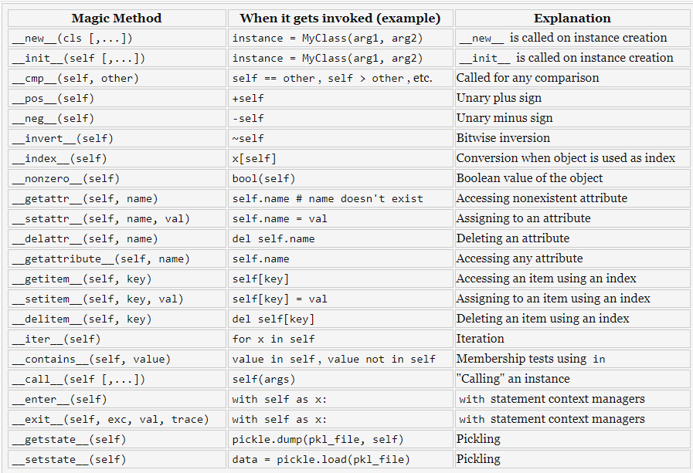

### **Q11. What are docstrings in Python? __doc__?**

Python docstrings are the string literals that appear right after the definition of a function, method, class, or module. It is accessible from the doc attribute __doc__ or built-in function: help(). dir() function returns all properties and methods of the specified object. help() function just returns its docstring.

### **Q12. What is self in Python?**

Self is an instance or an object of a class. In Python, this is explicitly included as the first parameter. It helps to differentiate between the methods and attributes of a class with local variables. The self variable in the init method refers to the newly created object while in other methods, it refers to the object whose method was called.

### **Q13. What are deep copy (copy.deepcopy)? shallow copy (copy.copy)?**

A shallow copy constructs a new compound object and then (to the extent possible) inserts **references** into it to the objects found in the original. A deep copy constructs a new compound object and then, recursively, inserts **copies** into it of the objects found in the original.

### **Q14. What are local variables and global variables in Python? How to access a global variable in a function?**

**Global Variables**: Variables declared outside a function or in global space are called global variables. These variables can be accessed by any function in the program. GLOBAL Keyword is used to access/modify the variables out of the current scope.

**Local Variables**: Any variable declared inside a function is known as a local variable. This variable is present in the local space and not in the global space.

### **Q15. What is type conversion in Python?**

Type conversion refers to the conversion of one data type into another.

int() – converts any data type into integer type

float() – converts any data type into float type

ord() – converts characters into integer

hex() – converts integers to hexadecimal

oct() – converts integer to octal

tuple() – This function is used to convert to a tuple.

set() – This function returns the type after converting to set.

list() – This function is used to convert any data type to a list type.

dict() – This function is used to convert a tuple of order (key,value) into a dictionary.

str() – Used to convert integer into a string.

complex(real,imag) – converts real numbers to complex(real,imag) numbers.

### **Q16. What are the built-in types of python?**

Integers

Floating-point

Complex numbers

Strings

Boolean

Built-in functions

### **Q17. All built-in functions of Python**

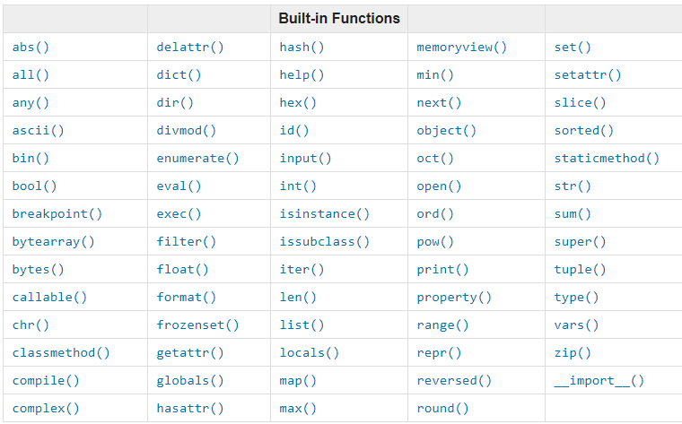

#### **map()**

map function executes the function given as the first argument on all the elements of the iterable given as the second argument. If the function given takes in more than one argument, then many iterables are given.

#### **help()**

help() function is to display the documentation string and also facilitates you to see the help related to modules, keywords, attributes, etc.

#### **dir()**

The dir() function returns all properties and methods of the specified object, without the values. This function will return all the properties and methods, even built-in properties which are default for all objects.

### **Q18. All String functions of Python**

refer to file “00_04_StringFunctions.py”

myString.capitalize() # capitalize the first letter of string

myString.upper() # translate to all uppercase letters

myString.lower() # translate to all lower case letters

myString.title() # capitalize the first character of each words

myString.swapcase() # uppercase to lowercase; lowercase to uppercase

myString.find(“i”) #return the index of first finding substring, -1 if not found.

myString.index(“i”) # same with find() but return error if not found.

myString.replace(“s”, “d”, 2) #src, dest, times

myString.split(“i”, 2) # delimiter, times myString.rsplit(“i”,2) # starting at the right side.

string connection: **a + b** , **(“%s %s”)%(a, b)** , **“ “.join([a, b])**

string to ASCII: print(ord(“a”)) print(chr(ord(“a”)))

### **Q19. All keywords of Python**

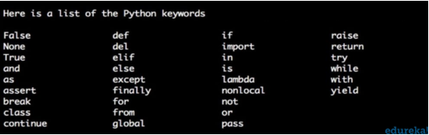

**import keyword**

**print(keyword.kwlist)**

**#this will get you the list of all keywords in python.**

**print(keyword.iskeyword('try'))**

**#this will return true, if the mentioned name is a keyword.**

### **Q20. What does this mean: *args, **kwargs? Why would we use it?**

We use *args when we aren’t sure how many arguments are going to be passed to a function. **kwargs is used when we don’t know how many keyword arguments will be passed to a function.

### **Q21. What is the difference between list and tuples in Python?**

|  |  |
| --- | --- |
| Lists are mutable i.e they can be edited. | Tuples are immutable (tuples are lists which can’t be edited). |
| Lists are slower than tuples. | Tuples are faster than list. |
| Syntax: list_1 = [10, ‘Chelsea’, 20] | Syntax: tup_1 = (10, ‘Chelsea’ , 20) |

### **Q22. Why is List slower than Tuple?**

List is slower than Tuple because Tuple has a smaller memory. List is stored in two blocks of memory (one is fixed size and the other is variable size for storing data) and Tuple is stored in one memory block. So creating a List is slower than creating Tuple.

* Tuple created with () round brackets
* List created with [] square brackets
* Dictionary created with {} curly brackets

### **Q23. What is the difference between Python Arrays and lists?**

Arrays and lists, in Python, have the same way of storing data. But, arrays can hold only a single data type element whereas lists can hold any data type elements. Example:

**import array as arr**

**My_Array=arr.array('i',[1,2,3,4])**

**My_list=[1,'abc',1.20]**

### **Q24. What advantages do NumPy arrays offer over Python lists?**

We use python NumPy array instead of a list because of the below three reasons:

1. Less Memory
2. Fast
3. Convenient

The very first reason to choose python NumPy array is that it occupies less memory as compared to list. Then, it is pretty fast in terms of execution and at the same time, it is very convenient to work with NumPy. So these are the major advantages that Python NumPy array has over list.

### **Q25. What is a lambda function?**

A lambda function is a small anonymous function. It can take any number of arguments but can have just one statement. Example:

**a = lambda x,y : x + y**

**print(a(5, 6))**

### **Q26. How can the ternary operators be used in python?**

The Ternary operator is the operator that is used to show the conditional statements.

This consists of the true or false values with a statement that has to be evaluated for it. Example: big = x if x < y else y

### **Q27. How does break, continue and pass work?**

|  |  |
| --- | --- |
| Break | Allows loop termination when some condition is met and the control is transferred to the next statement. |
| Continue | Allows skipping some part of a loop when some specific condition is met and the control is transferred to the beginning of the loop |
| Pass | Used when you need some block of code syntactically, but you want to skip its execution. This is basically a null operation. Nothing happens when this is executed. |

### 

### **Q28. What are negative indexes and why are they used?**

The sequences in Python are indexed and it consists of the positive as well as negative numbers. The index for the negative number starts from ‘-1’ that represents the last index in the sequence and ‘-2’ as the penultimate index and the sequence carries forward like the positive number.

The negative index is used to remove any new-line spaces from the string and allow the string to except the last character that is given as S[:-1]. The negative index is also used to show the index to represent the string in correct order.

### **Q29. What does [::-1] do?**

[::-1] is used to reverse the order of an array or a sequence.

[::-1] reprints a reversed copy of ordered data structures such as an array or a list. the original array or list remains unchanged.

### **Q30. How can you randomize the items of a list in place in Python?**

**from random import shuffle**

**x = ['Keep', 'The', 'Blue', 'Flag', 'Flying', 'High']**

**shuffle(x)**

**print(x)**

The output of the following code is as below.

['Flying', 'Keep', 'Blue', 'High', 'The', 'Flag']

### **Q31. How can you generate random numbers in Python?**

Random module is the standard module that is used to generate a random number. The method is defined as:

**import random**

**random.random**

### **Q32. What is the difference between range & xrange?**

For the most part, xrange and range are the exact same in terms of functionality. They both provide a way to generate a list of integers for you to use, however you please. The only difference is that range returns a Python list object and xrange returns an xrange object.

This means that xrange doesn’t actually generate a static list at run-time like range does. It creates the values as you need them with a special technique called yielding. This technique is used with a type of object known as generators. That means that if you have a really gigantic range you’d like to generate a list for, say one billion, xrange is the function to use.

This is especially true if you have a really memory sensitive system such as a cell phone that you are working with, as range will use as much memory as it can to create your array of integers, which can result in a Memory Error and crash your program. It’s a memory hungry beast.

### **Q33. What is pickling and unpickling?**

Python pickle module is used for serializing and de-serializing a Python object structure. Any objects in Python can be pickled so that it can be saved on disk.

**import pickle**

**data = {"key" : "value"}**

**file = open('data.txt', 'wb') # must be binary mode**

**pickle.dump(data, file)**

**file.close()**

**readfile = open('data.txt', 'rb') # must be binary mode**

**dataloaded = pickle.load(readfile)**

**readfile.close()**

**print(dataloaded)**

### **Q34. Iterator**

An iterator is an object that contains a countable number of values. In Python, an iterator is an object which implements the iterator protocol, which consists of the method __iter__() and __next__(). Refer to **00_02_03_Iterator and Generator.py**

### **Q35. Keyword ‘yield’, Generator and Generator Expression**

Generator is an easy method to build an iterator with the keyword ‘yield’. When the function contains a ‘yield’ statement, it becomes a generator function and returns an iterator object. ‘yield’ statement pauses the function saving all its states and later continues from there on successive calls. Generator Expression is to create anonymous generator functions, like: **myGenerator = (x**2 for x in range(5))**

### **Q36. Decorator**

Decorators is a wrapper of function in order to extend the behavior of wrapped function, without permanently modifying it. Decorators use the sign of “@”. Since decorators are a callable object so class, function could be decorators. Some real cases: recording the run time of function, log information of function.

### **Q37. monkey patching**

The term monkey patch only refers to dynamic modifications of a class or module at run-time.

### **Q38. What is the difference between eval() and exec()?**

eval() returns the run result but exec() not.

### **Q39. @property**

@property is a built-in decorator for the property() function in Python. It is used to give “special” functionality to certain methods to make them act as getters, setters, deleters when we defined properties in a class (For encapsulation)

## 

# **OOPS Interview Questions**

### **Q1. Inheritance**

Inheritance allows One class to gain all the members(say attributes and methods) of another class. Inheritance provides code reusability, makes it easier to create and maintain an application. The class from which we are inheriting is called superclass and the class that is inherited is called a derived / child class.

They are different types of inheritance supported by Python:

**Single Inheritance** – where a derived class acquires the members of a single super class.

**Multiple inheritance** – a derived class is inherited from more than one base class.

**Multilevel inheritance** – a derived class d1 is inherited from base class base1, and class base1 is inherited from class base2.

### **Q2. Encapsulation**

Encapsulation means binding the code and the data together. A Python class in an example of encapsulation

### **Q3. Polymorphism**

Polymorphism means the ability to take multiple forms. So, for instance, if the parent class has a method named ABC then the child class also can have a method with the same name ABC having its own parameters and variables. Python allows polymorphism.

### **Q4. Namespace**

A namespace is basically a system to make sure that all the names in a program are unique and can be used without any conflict.

在python中，如果要访问某一个对象（包括变量，模块，方法等）都是会去namespace中根据对象名称去检索，这里涉及到一个检索顺序，称为：LEGB

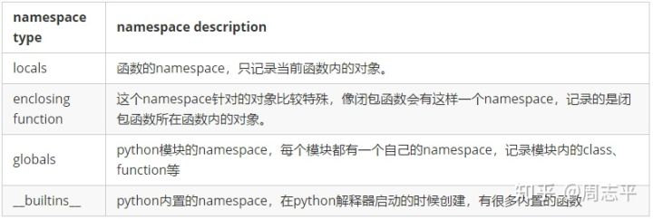

locals -->> enclosing function -->> globals -->> __builtins__

### **Q5. Private and Protected Modifiers**

Python uses the ‘_’ symbol to determine the access control for a specific data member or a member function of a class.

Protected Access Modifier:The members of a class that are declared protected are only accessible to a class derived from it. Data members of a class are declared protected by adding a single underscore ‘_’ symbol before the data member of that class. It can be accessed but not do it.

Private Access Modifier: The members of a class that are declared private are accessible within the class only, private access modifier is the most secure access modifier. Data members of a class are declared private by adding a double underscore ‘__’ symbol before the data member of that class. (_Class__Variable)

### **Q6. How to create an empty class in Python?**

An empty class is a class that does not have any code defined within its block. It can be created using the ***pass*** keyword. However, you can create objects of this class outside the class itself. IN PYTHON THE PASS command does nothing when it's executed. it’s a null statement.

### **Q7. What does an object() do?**

The object() function returns an empty object. We cannot add any new properties or methods to this object. It is the base for all classes (built-in properties and methods).

### **Q8. What is the difference between Class attribute and Instance attribute?**

# **re module**

### **meta characters**

[ ] open square brackets/close square brackets: a set of characters

**\** backslash : a special sequence

**.** period, dot : any character

^ caret : starts with $ dollar : end with

* asterisk : zero or more occurrences

+ plus : one or more occurrences

{} curly brackets : exactly the specified number of occurrences.

| bar : either or

() round brackets : capture and group

### **special sequence**

\A at the beginning of the string, r”\Aaaa”

\b at the beginning or end of a word, r”\baaa” or r”aaa\b”

\B matched but not at the beginning or end.

\d number 0~9 \D not 0~9

\s space \S not space

\w a~Z and 0~9, _ (underscore) \W not \w

\Z at the end. r”cc\Z”

### **sets**

A set is a set of characters inside a pair of square brackets [ ]

[^ard] not a, r, d

[+] character +, any meta characters will miss their meaning just characters.

### **functions**

#### **findall()**

x = re.findall(“\w\d”, string) # x is a list returned with all matched strings or empty list.

#### **search()**

x = re.search(“\s”, string) # x is a **matched object** or None

#### **split()**

uses a regex pattern to “split” a given string into a list.

x = re.split(“\s”, string) # returns a list

#### **sub()**

finds all substrings where the regex pattern matches and then replace them with a different string.

x = re.sub(“\s”, “|”, string) # replace string with what you input

#### **subn()**

similar with sub() but returned the replaced string and the number of replacements.

### **matched object**

groups()

returns all matched, captured group

group(1)

returns the first captured group

start(1)

returns the start index of first captured group

end(1)

returns the end index of first captured group

span(1)

returns the start and end index of first captured group as a list

string: returns the raw string

lastIndex: returns the index of the last matched group, 2 means 2 matched groups.

# **NumPy**

# **Pandas**